

DELAYED-RELEASE UNDER-ICE DRIFTER (DRUID) BUOY   
PRE-DEPLOYMENT PROCEDURES  
SUMMER / FALL 2018

Point of Contact   
LT Dan Langis  
daniel.langis@noaa.gov   
office 206-526-4804  
  
LTJG Sarah Donohoe  
sarah.s.donohoe@noaa.gov   
office 206-526-6746  
  
Background  
The delayed-release under-ice drifter (DRUID) buoys are one of several new technologies in development by the Innovative Technology for Arctic Exploration (ITAE) grant. DRUID buoys were developed to collect data on under-ice phytoplankton/algal blooms and the character of the ice-water boundary. They are compact instruments housed in low-cost commercial crab floats and optimized for use in the relatively shallow waters of the Arctic continental shelf. The buoys are expendable and capable of providing approximately 6 months of under-ice data transmitted via Iridium short-burst-data messages; designed to be sunk with an anchor and a timed burn-wire release at sea during late summer to early fall in ice-free conditions. Our objective is to release the buoys from their anchorages once the sea ice has advanced overhead, usually around late-winter to early-spring. At a pre-programmed release date the burn wire will release the anchor and the sensors will capture a single water column profile as it rises and gets trapped under the ice. In this phase the DRUID collects oceanographic data on conditions directly under Arctic sea ice during spring and early summer. Once the Arctic sea ice retreats and the float is freed the DRUID begins transmitting stored data and location until battery life is fully drained.

**Pop-Up Deployment Procedure**

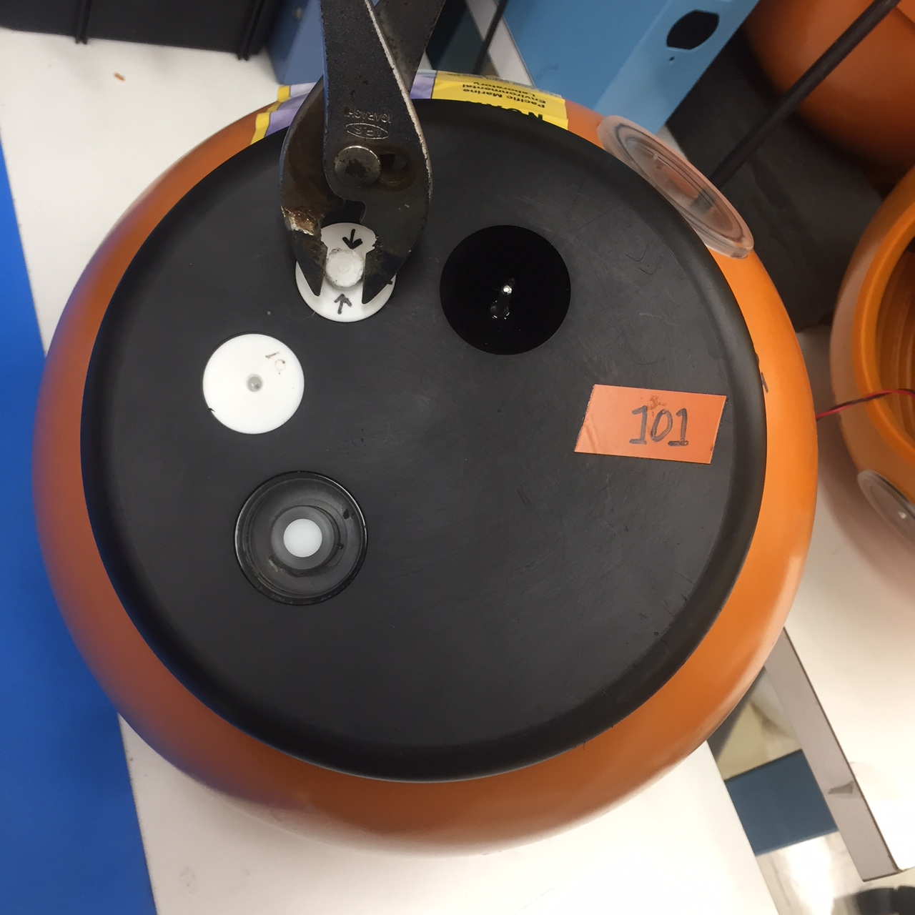**1) Pump Vacuum to -10psi**

1. **Remove the vacuum cap plug (marked by arrows) with pliers.**

1a

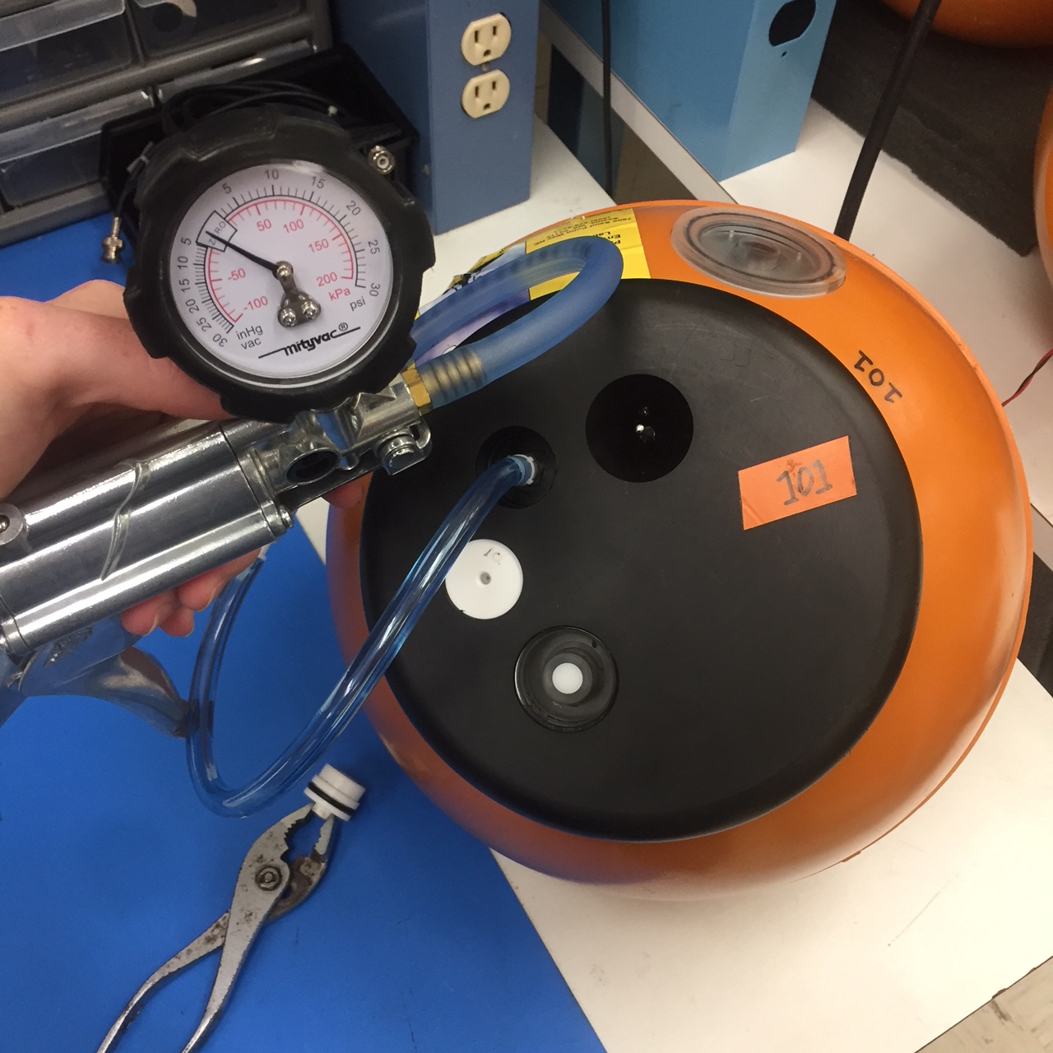Keep in mind the O-ring on this plug must be kept clean and free of dust or debris. It is the only thing keeping water from entering the valve and flooding the DRUID.

1b

1. 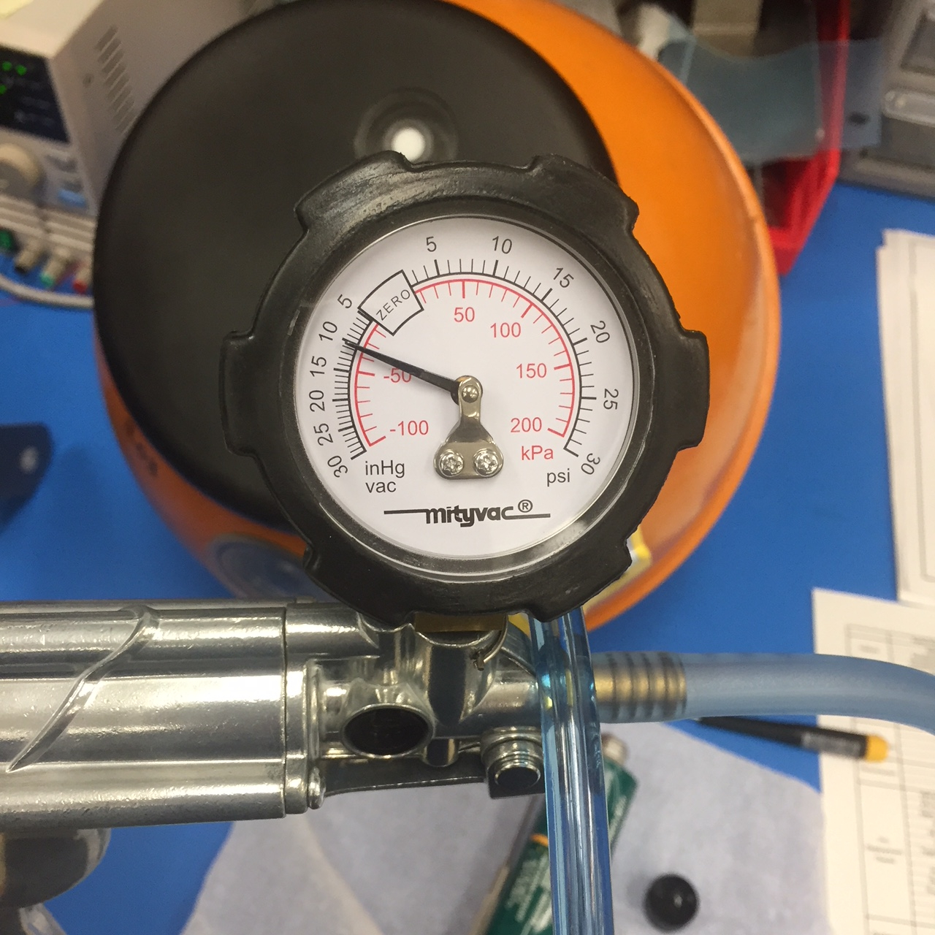**Attach the hand-pump hose.**   
   The valve attachment on the hose should twist ¼ turn clockwise and lock in place. Use pliers if your fingers don’t fit in the cutout.  
   *\*\*Please write down vacuum pressure before pumping on deployment sheet.*

1c

1. 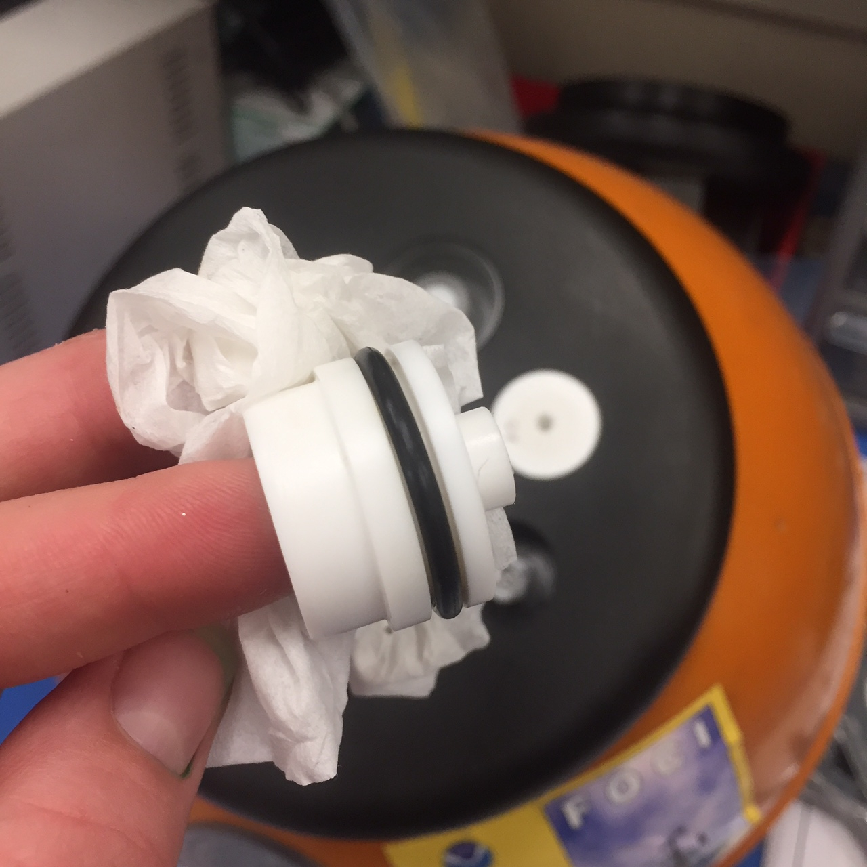**Pump air out until gauge reads -10psi. Be sure the switch at the hand pump nozzle is set to vacuum (not pressure).**  
   This may take ~100 squeezes. *\*\*Please write down vacuum pressure after pumping on deployment sheet.*

1d

1. 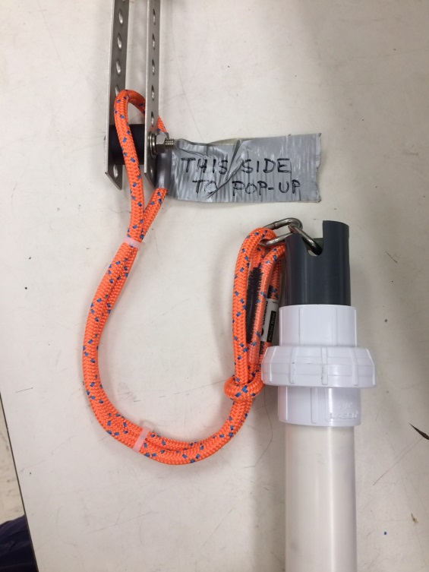**Clean the vacuum cap plug and mating surface on the float. Re-grease O-ring if necessary. Replace plug.**

2

To replace the plug, you can use pliers to push down until the lower surface of the plug top is flush or below the black end cap surface. It is ok if the smaller raised portion sticks up above the end cap surface slightly.

**2) Attach Release**

**(Units 101 and 102 only)**  
**Attach orange line to pop-up frame.**

Remove lowermost bolt, loop line around black spacer, reattach and re-tighten bolt.

**3) Attach Anchor**  
For units 101 and 102, attach the anchor to the green line on the release.

For unit 103, attach the anchor line to the shackle which is on the black release link.

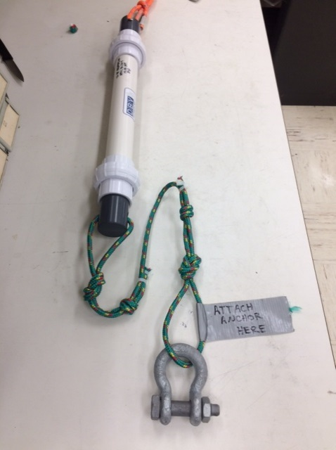

3